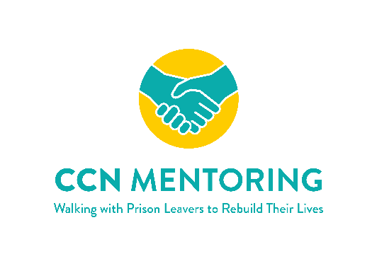
Application to Volunteer with Community Chaplaincy Norfolk
Name:
Address:
Email address:
Phone Number:
Why do you want to volunteer with CCN Mentoring?

Please give brief details of any relevant experience (i.e., mentoring or coaching; knowledge of the Criminal Justice system; supporting people with high levels of vulnerability, etc.)

Return to abby@norfolkchaplaincy.org.uk or by post to CCN Mentoring, c/o St. Stephen’s Church, 2 Rampant Horse Street, Norwich, NR2 1QP

