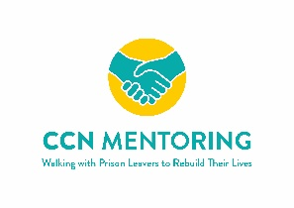
Community Chaplaincy Norfolk
Donation and Gift Aid Declaration Form Registered Charity no. 1180579
Please make cheques payable to Community Chaplaincy Norfolk, complete each section of this form, sign and return to:

Community Chaplaincy Norfolk, c/o St Stephen’s Church, 2 Rampant Horse Street, Norwich, NR2 1QP
If you prefer to make a direct bank transfer, please email us on info@norfolkchaplaincy.org.uk for bank details.
Thank you for your support.
Title: First name(s):
Surname:
Home address and postcode:
Telephone number:
Email address:
I would like my donation to be anonymous (please circle) yes no
Your support makes our work possible. We would like to keep you updated and keep in touch. If you would like us to send you information by email, please tick the box
Gift Aid Declaration Please tick the appropriate box
Please treat
The enclosed gift of £ ………………. as a Gift Aid Donation; OR
All gifts of money I make today and in the future as Gift Aid donations;
I am a UK taxpayer and understand that if I pay less Income Tax and/or Capital Gains Tax than the amount of Gift Aid claimed on all my donations in that tax year it is my responsibility to pay any difference.
Signature………………………………………………………………. Date…………………………………………………..
Please notify Community Chaplaincy Norfolk if you
1. Want to cancel this declaration.
2. Change your name or home address.
3. No longer pay sufficient tax on your income and / or capital gains.

• Community Chaplaincy Norfolk will reclaim 25p of tax on every £1 you give.
• If you pay Income Tax at the higher or additional rate and want to receive the additional tax relief due to you, you must include all your Gift Aid donations on your Self-Assessment tax return or ask HM Revenue and Customs to adjust your tax code.

